Technical Design for Shadow Rendering

Revision History

Issue | Date | Person | Reason
0.1 | March 05, 2002 | Darryl Long | Created
1.0 | April 12, 2002 | Darryl Long | Reviewed by team and released

Description

Introduction
The volumetric shadow and light rendering component is responsible for rendering dynamic shadows for moving objects and vehicles and casting “beams” of light from certain light sources.

The volumetric shadow must be projected from the source object in the direction of the light vector until contacting a surface object. The volumetric light must project along the light vector with a fall-off value until either contacting a surface or the intensity is sufficiently small.

The algorithms for these two operations are nearly identical thus they have been grouped into a single component.

Requirements

- Use the same algorithm as implemented for SRR on XBox
- Unify platform implementations as much as possible (use a stencil buffer)
- Volumetric lights and shadows (additive and subtractive blending)
- Fix problems with multiple-level terrain (such as bridges)
- Optimize for distance from the destination surface
- Optimize with “lazy calculations” of the silhouette

References
- Talked to Josh about the implementation from SRR
- Talk to Yayoi about need for volumetric shadows and lights
- Talked to Amit and Senta about PS2 and GC stencil buffers
- Talked to Devin about some technical problems of shadows for SRR

Technical Design

Relationships
This component will have to work very closely with the Rendering Engine to track the position of world objects with shadows and/or lights.

The component must know how to find the surface onto which the shadow or lights will be projected, and find the longest distance between the silhouette edge and the surface. Therefore, it will depend on the World Manager component.

Any world object that required a shadow needs to have a CShadowGenerator object and render it.

Interface
The Shadow algorithm using a stencil buffer was previously implemented and is proven to work.

A CShadowGenerator is a class for holding data to create the outline of the geometry.

class CShadowGenerator : public tRefCounted
{
public:
CShadowGenerator();
~CShadowGenerator();

void SetLight(tLight* pLight);
void SetOffset(rmt::Vector offset);

void Begin();
void End();

const rmt::Vector GetShadowVector();

void SetShadowVector(const rmt::Vector& v);
void SetShadowColour(tColour c);

void SetScalar(float scale) { shadowScale = scale; };

tColour GetShadowVolumeColour();
};

The CPrimGroupShadow holds data required to render an already generated shadow.

class CPrimGroupShadow : public tDrawable
{
public:
CPrimGroupShadow(tPrimGroupStreamed *pSource);
~CPrimGroupShadow();

void Update();
void Display();

rmt::Vector* GetVertices() {return m_pVertex;}
unsigned short GetNumVertices() {return m_NumVertex;}

void SetGenerator(CShadowGenerator* pGenerator);
CShadowGenerator* GetGenerator() {return m_pGenerator;}
};

Any object which wants to have a shadow must have a CShadowGenerator. It passes the CShadowGenerator to the mesh which generates one or more CPrimGroupShadow. The CPrimGroupShadows are rendered.

Component Class Diagrams
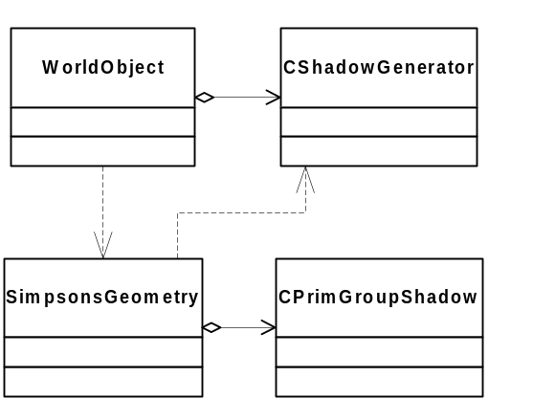

Use Cases

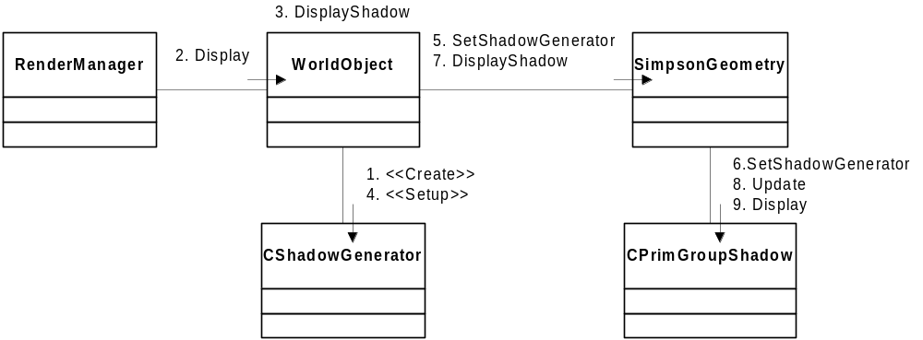

Here is an example of a vehicle which prepares a CShadowGenerator based on its location and distance from the ground.

void Vehicle::DisplayShadow() const
{

tCamera* cam = p3d::context->GetView()->GetCamera();
SimpsonGeometry* mesh = (SimpsonGeometry*) chassisShadowGeometry;

// reduce the shadow draw distance.
// the call to GetIntersects is expensive.
float shadowDrawDistance = 100.0f;

float oldFarPlane = cam->GetFarPlane( );
cam->SetFarPlane( shadowDrawDistance );

bool fogState = p3d::pddi->IsFogEnabled();
p3d::pddi->EnableFog(false);

tSphere sphere;

mesh->GetBoundingSphere(&sphere);
sphere.centre.Set( chassisExaggerationMatrix.m[3][0], chassisExaggerationMatrix.m[3][1], chassisExaggerationMatrix.m[3][2] );

if ( cam->SphereVisible( sphere.centre, sphere.radius ) )
{
rmt::Vector lightOffset;

lightOffset.x = chassisExaggerationMatrix.m[3][0];
lightOffset.z = chassisExaggerationMatrix.m[3][2];
lightOffset.y = 0.0f;

shadowGenerator->SetOffset( lightOffset );

bool drawShadow = false;

tBox3D box;
mesh->GetBoundingBox(&box);

if(parentVehicle->shadowOnTerrain)
{
float y;
rmt::Vector groundNormal;

SG::gridManager.GetIntersects((void*)this, chassisMatrix.m[3][0], chassisMatrix.m[3][2], y, groundNormal);

float scaler = chassisExaggerationMatrix.m[3][1] - y + box.pmax.y + 1.0f;

if( scaler > 12)
{
//No shadow
}
else
{
drawShadow = true;
shadowGenerator->SetScalar(scaler);
}
}
else if(parentVehicle->carInAirAboveStaticObj)
{

// don't draw shadow?

}
else
{
float y;
rmt::Vector groundNormal;

SG::gridManager.GetIntersects((void*)this, chassisMatrix.m[3][0], chassisMatrix.m[3][2], y, groundNormal);

float scaler = chassisMatrix.m[3][1] - parentVehicle->shadowPoint.y + box.pmax.y + 1.0f;

if( scaler > 12)
{
//No shadow
}
else
{
drawShadow = true;
shadowGenerator->SetScalar(scaler);
}

}

if(drawShadow)
{
p3d::stack->Push();
//p3d::stack->Multiply(chassisMatrix);
p3d::stack->Multiply(chassisExaggerationMatrix);
mesh->SetGenerator(shadowGenerator);
mesh->DisplayShadow();

p3d::stack->Pop();
}
}

p3d::pddi->EnableFog(fogState);

cam->SetFarPlane( oldFarPlane );

}

One of the final steps above is to set the CShadowGenerator of the mesh to the CShadowGenerator we had just prepared. The mesh for this object must be of the SimpsonsGeometry type. Each SimpsonsGeometry has a private member defined as:

CPrimGroupShadow** shadowPrimGroups;

SimpsonsGeometry::DisplayShadow() is defined as follows:

void SimpsonGeometry::DisplayShadow()
{
//Update all vertices
//Update per triangle normal
//Update culled information
//Compute edge list
//Draw quad's off edges

BEGIN_PROFILE( "DisplayShadow" )

for(int j=0; j < nPrimGroup; j++)
{

//Update the shadow edge
shadowPrimGroups[j]->Update();

// Stencil test passes if ((ref & mask) cmpfn (stencil & mask)) is true.
// Note: since we set up the stencil-test to always pass, the STENCILFAIL
// renderstate is really not needed.
p3d::pddi->SetStencilOp(PDDI_STENCIL_KEEP, PDDI_STENCIL_KEEP, PDDI_STENCIL_INCR);

pddiCullMode cullMode = p3d::pddi->GetCullMode();

// Draw front-side of shadow volume in stencil/z only
shadowPrimGroups[j]->Display();

//Inverted pass
p3d::pddi->SetCullMode(PDDI_CULL_INVERTED);
p3d::pddi->SetStencilOp(PDDI_STENCIL_KEEP, PDDI_STENCIL_KEEP, PDDI_STENCIL_DECR);
// Draw back-side of shadow volume in stencil/z only
shadowPrimGroups[j]->Display();

//Restore the state
p3d::pddi->SetCullMode(cullMode);

}
END_PROFILE( "DisplayShadow" )
}

